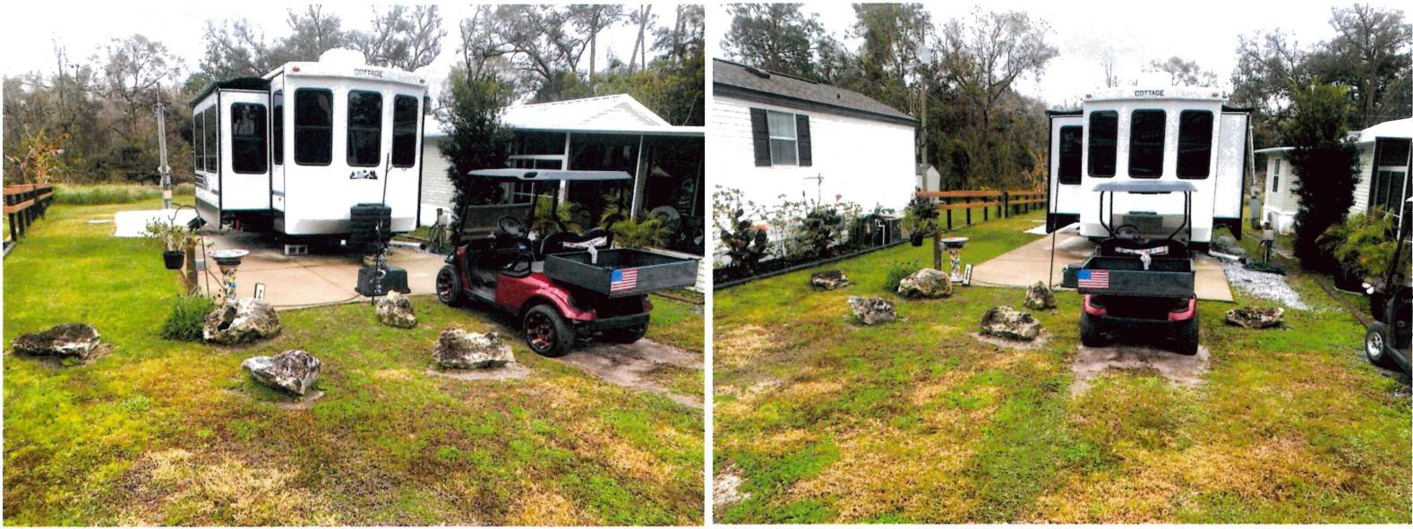
LOT 708 – Cherry Circle w/Share Asking $219,000
Spectacular 2024 Cottage 40 CDL Park Trailer with share for only
$219,000.00 on one of the most desirable streets in Sawmill 708 Cherry Circle.
- The lot is very deep with no neighbors behind you.
- The home features an open concept floor plan with a large kitchen with a nice island with dish washer & large refrigerator/freezer.
- The living room has a nice fireplace & large tv.
- Tucked behind the tv & fireplace is a floor to ceiling pantry for storing all your kitchen items.
- The bathroom has a large walk-in shower with several shower nozzles.
- The home has two spacious lofts & cabinet storage to store items.
- The home is able to host up to eight people. The main suite has an awesome king-size bed with added padding for a great night’s sleep. The bedroom also has a wall mounted tv & a large closet with washer/dryer hook up.
- Outside there is a large cement/paver entertainment area for enjoying outside activities.
- Please Google 2024 Cottage 40 CDL for more details & videos.
- The price also includes an EZ-GO golf cart with new batteries.

Please contact Vince for serious inquiries and schedule a tour 317-847-2990

